SASI KUMAR G

731621205049

Sasikumar9150476994”gmail.com

**Exercise 1**

**Main Task**

1. Create a new directory and change into it.

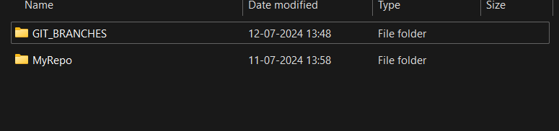

1. Use the **init** command to create a Git repository in that directory.

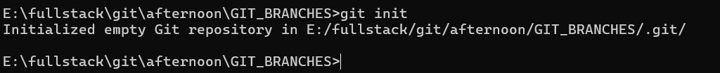

1. Observe that there is now a **.git** directory.

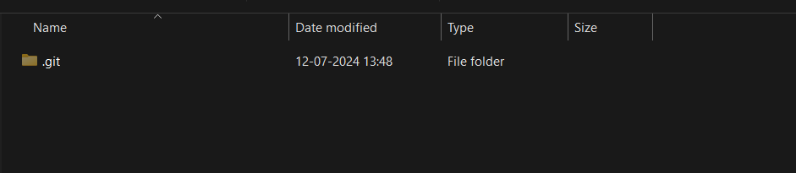

1. Create a **README** file.

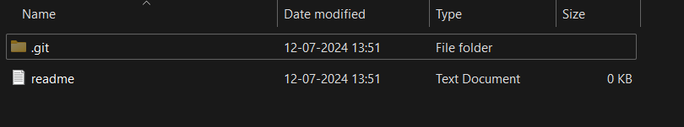

1. Look at the output of the **status** command; the **README** you created should appear as an untracked file.

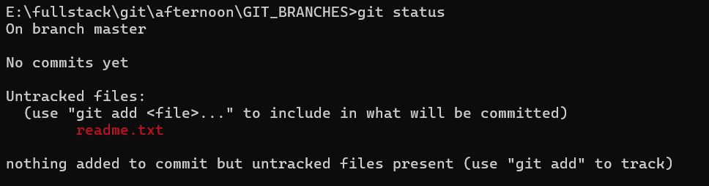

1. Use the **add** command to add the new file to the staging area. Again, look at the output of the **status** command.



1. Now use the **commit** command to commit the contents of the staging area.

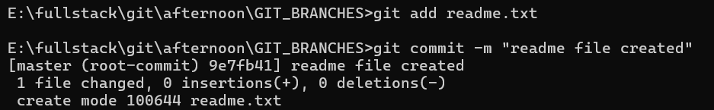

1. Create a **src** directory and add a couple of files to it.

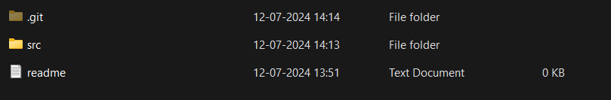

1. Use the **add** command, but name the directory, not the individual files. Use the **status** command. See how both files have been staged. Commit them.



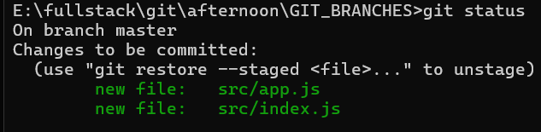

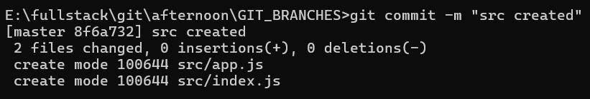

1. Make a change to one of the files. Use the **diff** command to view the details of the change.

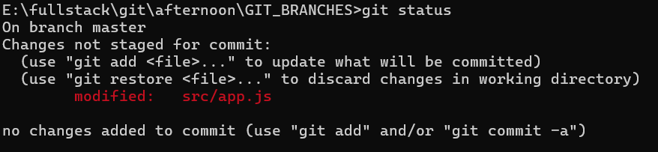

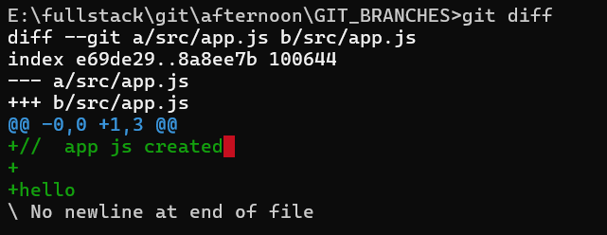

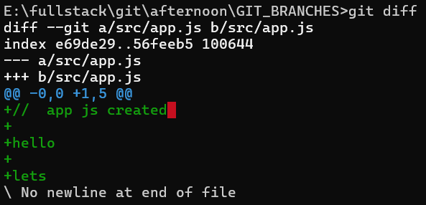

1. Next, **add** the changed file, and notice how it moves to the staging area in the **status** output. Also observe that the **diff** command you did before using add now gives no output. Why not? What do you have to do to see a **diff** of the things in the staging area? (Hint: review the slides if you can’t remember.)

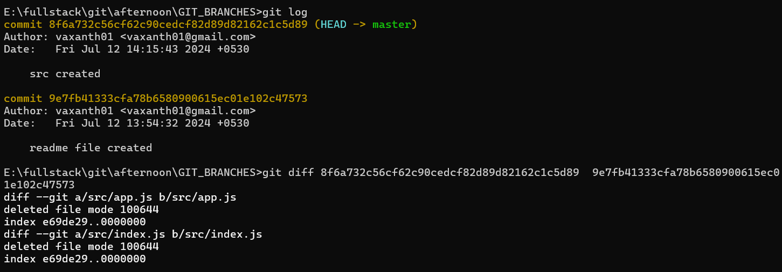

1. Now – without committing – make another change to the same file you changed in step 10. Look at the **status** output, and the **diff** output. Notice how you can have both staged and unstaged changes, even when you’re talking about a single file. Observe the difference when you use the **add** command to stage the latest round of changes. Finally, **commit** them. You should now have started to get a feel for the staging area.

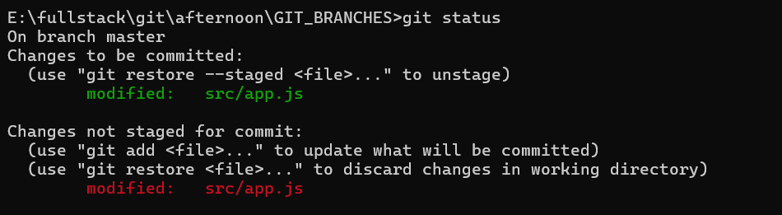

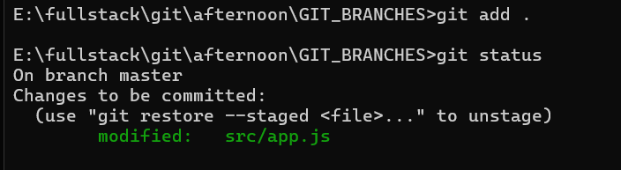

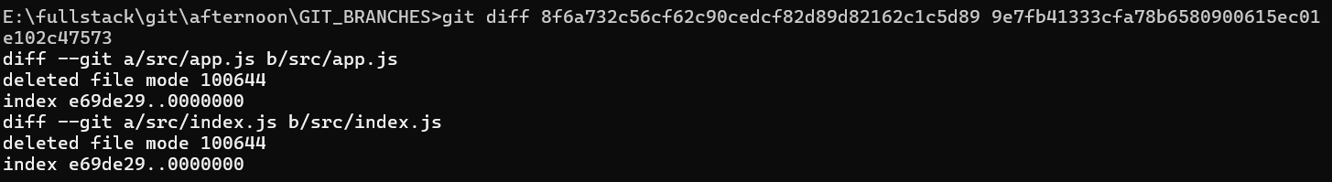

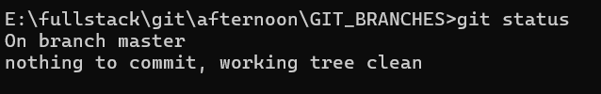

1. Use the **log** command in order to see all of the commits you made so far.

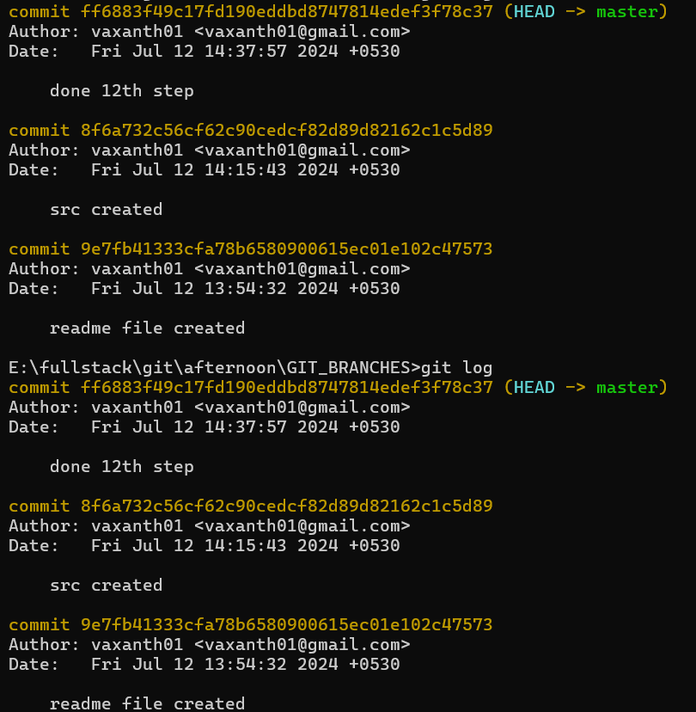

1. Use the **show** command to look at an individual commit. How many characters of the commit identifier can you get away with typing at a minimum?

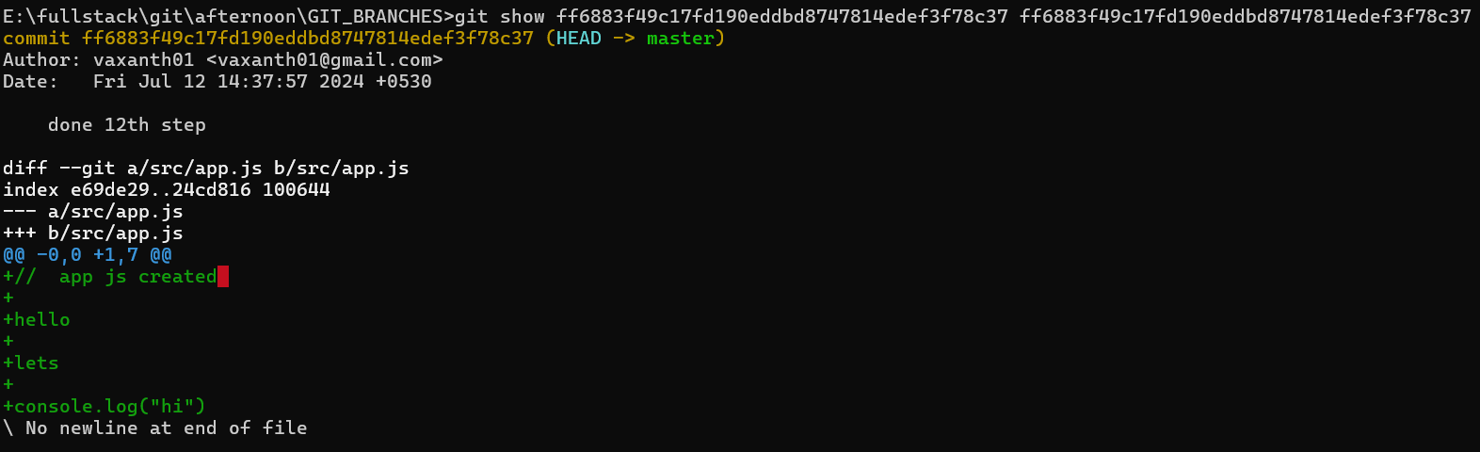

1. Make a couple more commits, at least one of which should add an extra file.

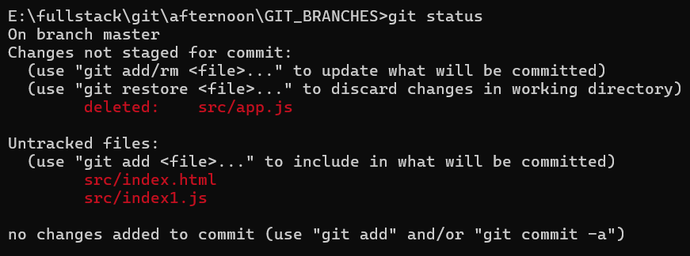

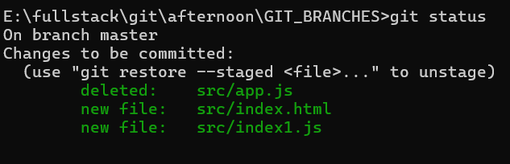

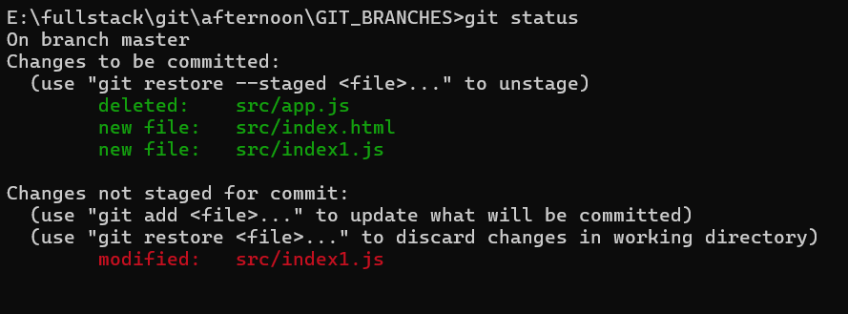

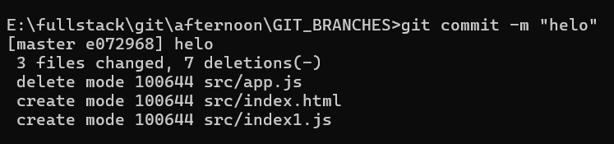

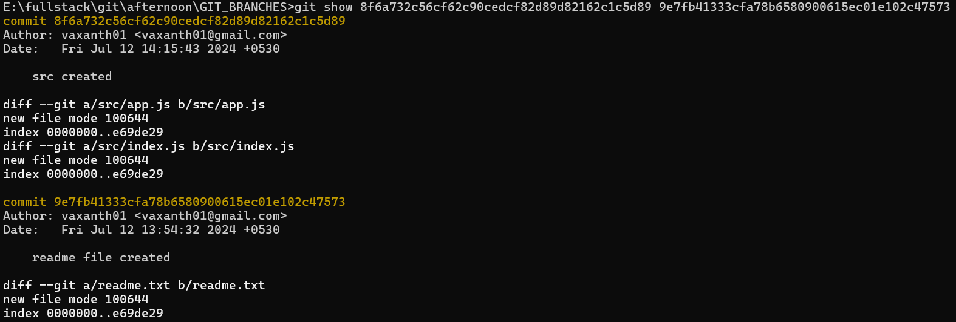

**Exercise 2**

**Main Task**

1. Run the **status** command. Notice how it tells you what branch you are in.

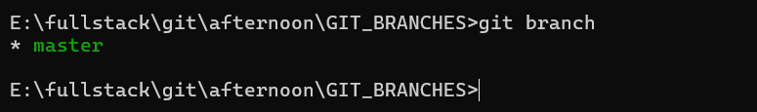

1. Use the **branch** command to create a new branch.

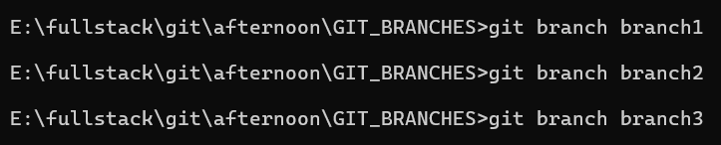

1. Use the **checkout** command to switch to it.

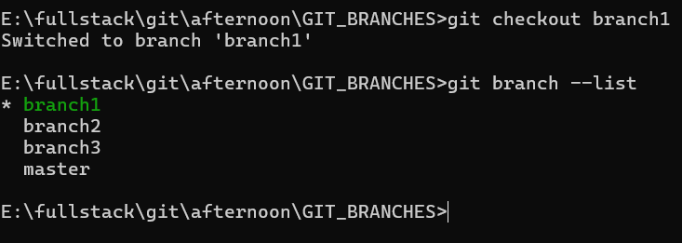

1. Make a couple of commits in the branch – perhaps adding a new file and/or editing existing ones.

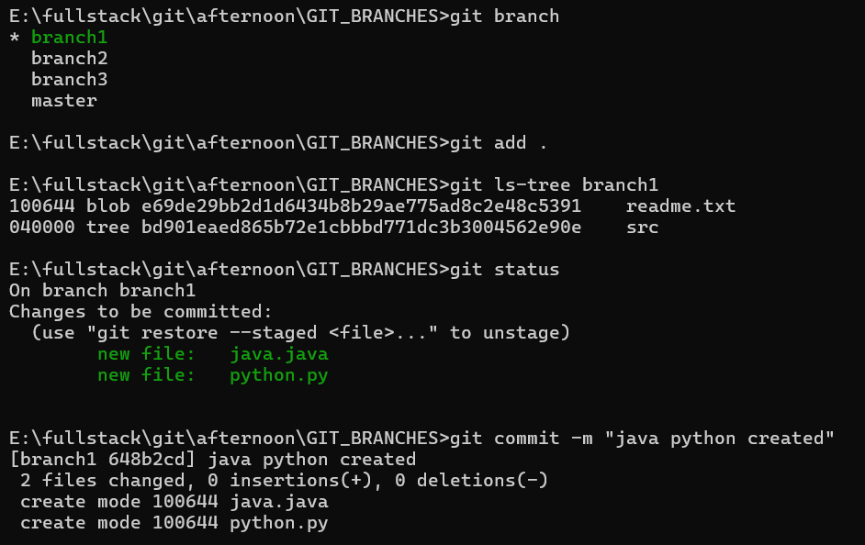

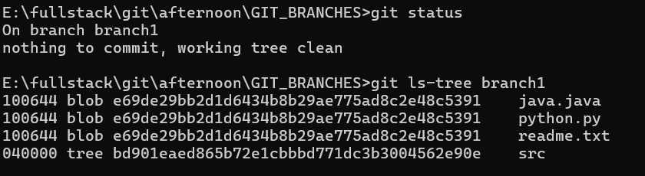

1. Use the **log** command to see the latest commits. The two you just made should be at the top of the list.

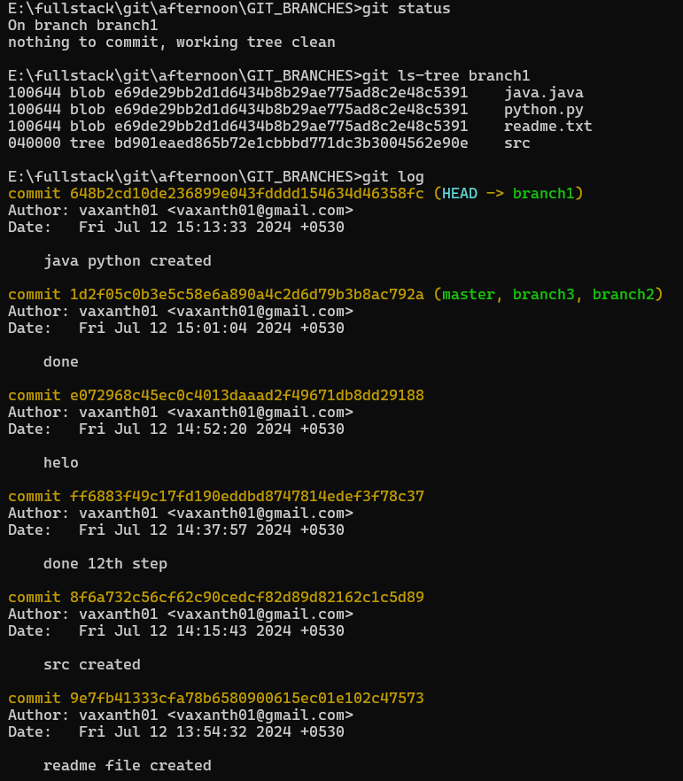

1. Use the **checkout** command to switch back to the master branch. Run **log** again. Notice your commits don’t show up now. Check the files also – they should have their original contents.

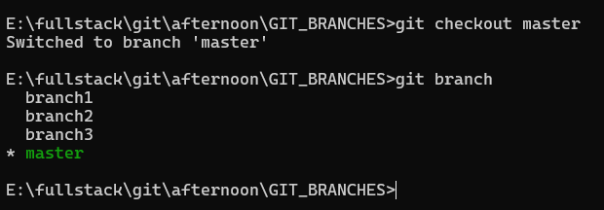

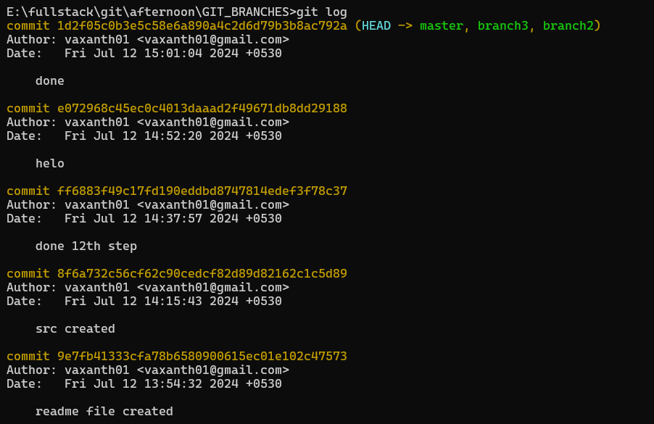

1. Use the **checkout** command to switch back to your branch. Use **gitk** to take a look at the commit graph; notice it’s linear.

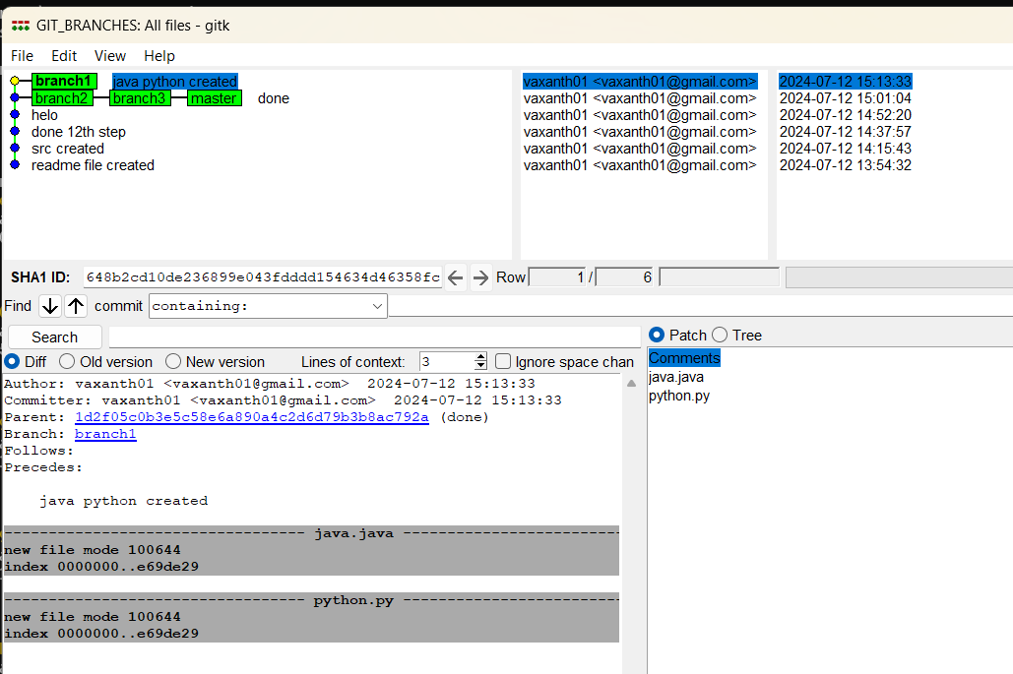

1. Now **checkout** the master branch again. Use the **merge** command to merge your branch in to it. Look for information about it having been a fast-forward merge. Look at **git log**, and see that there is no merge commit. Take a look in **gitk** and see how the DAG is linear.

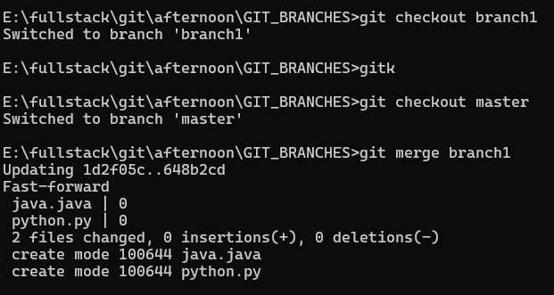

1. Switch back to your branch. Make a couple more commits.

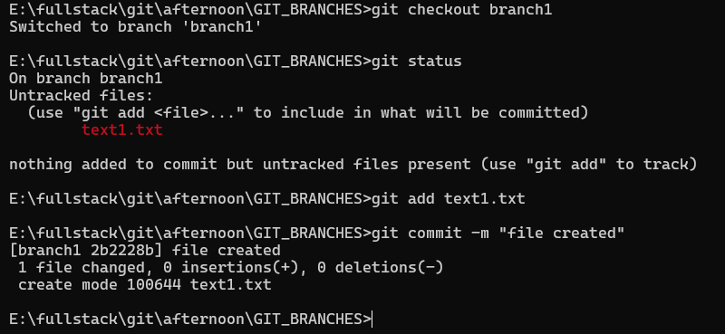

1. Switch back to master. Make a commit there, which should edit a different file from the ones you touched in your branch – to be sure there is no conflict.

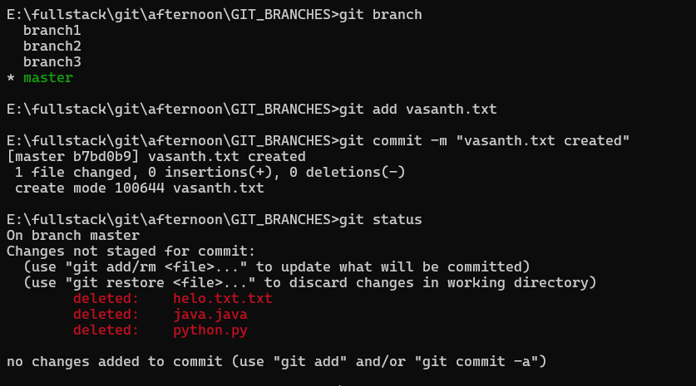

11. Now **merge** your branch again. (Aside: you don’t need to do anything to inform Git that you only want to merge things added since your previous merge. Due to the way Git works, that kind of issue simply does not come up, unlike in early versions of Subversion.)

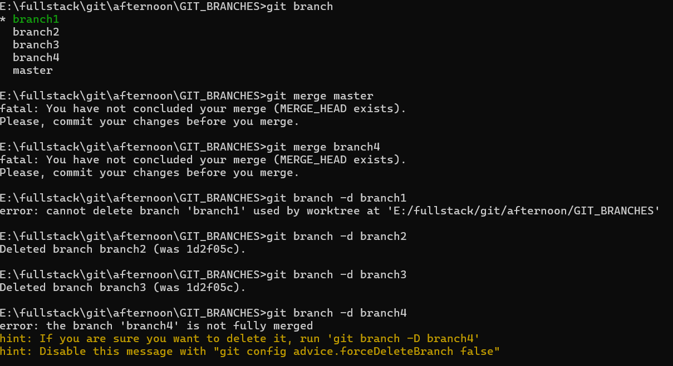

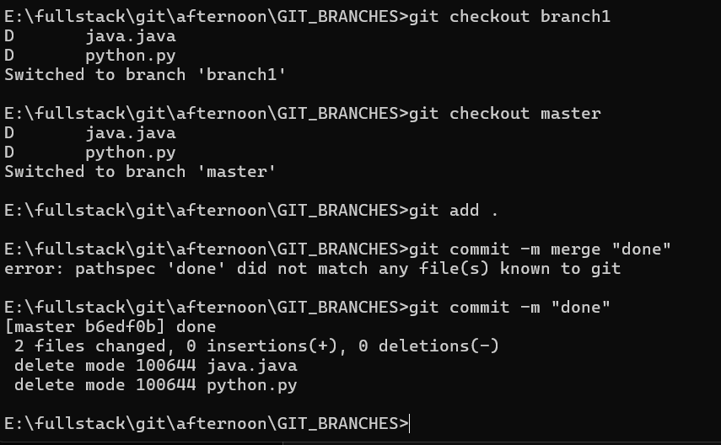

12. Look at **git log**. Notice that there is a merge commit. Also look in **gitk**. Notice the DAG now shows how things forked, and then were joined up again by a merge commit.

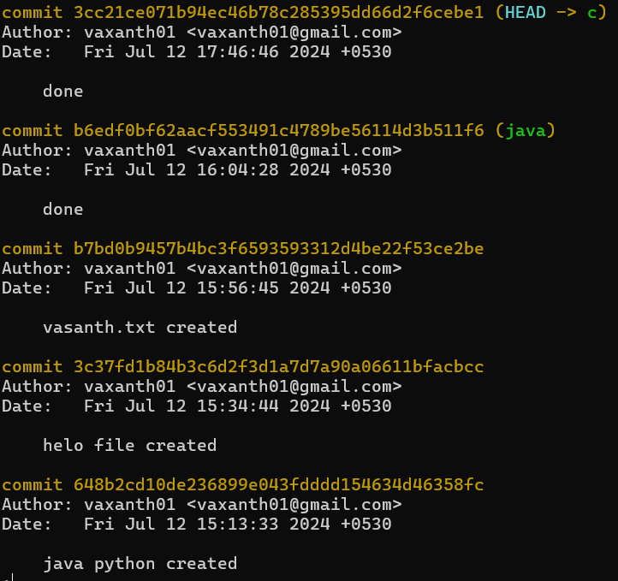

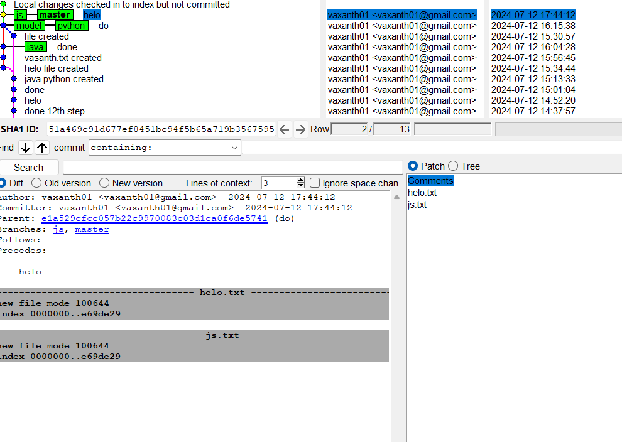

**Exercise 3**

For this task, you will work in a small group. Between 2 and 4 people is about right.

**Main Task**

1. First, one person in the group should create a public repository using their GitHub account.

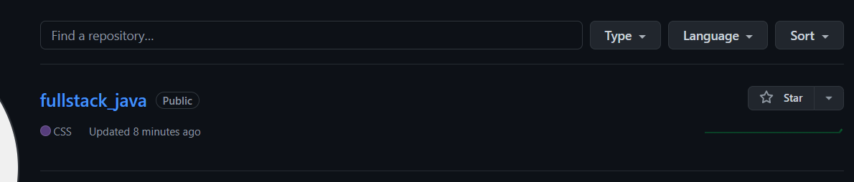

1. This same person should then follow the instructions from GitHub to add a **remote**, and then **push** their repository. Do not forget the **–u** flag, as suggested by GitHub!

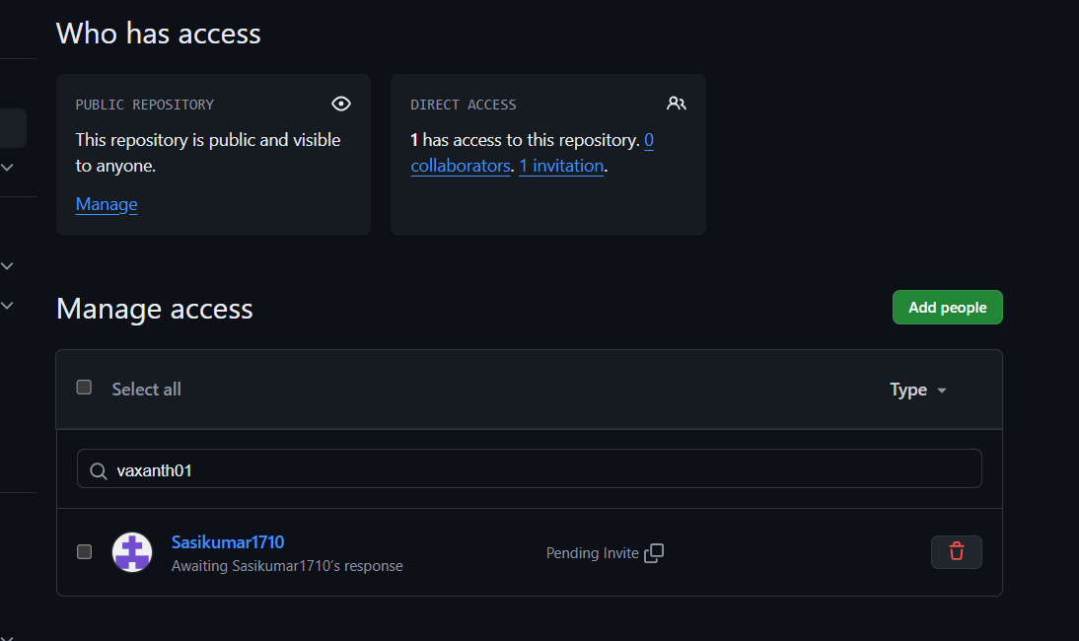

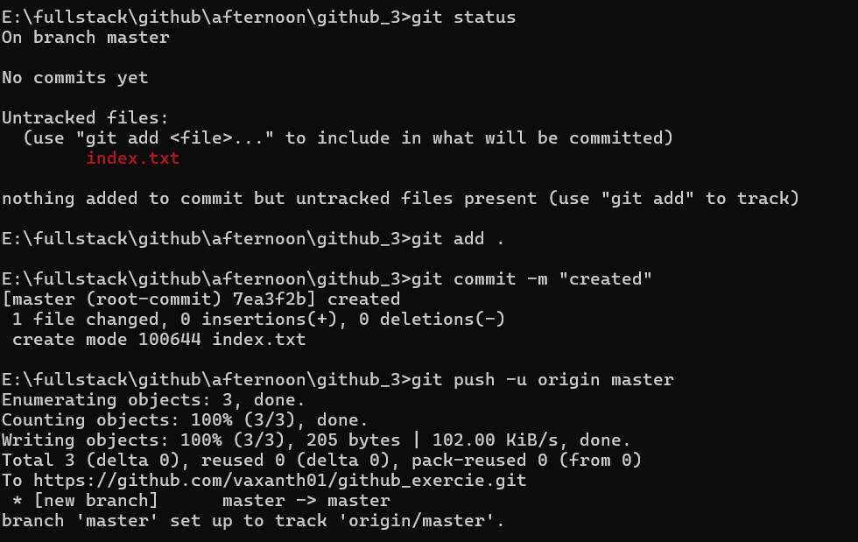

1. All of the other members of the group should then be added as collaborators, so they can commit to the repository also.

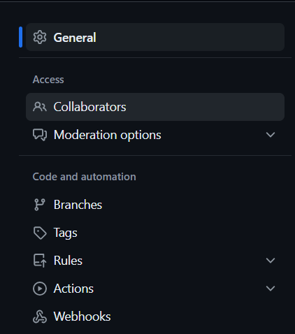

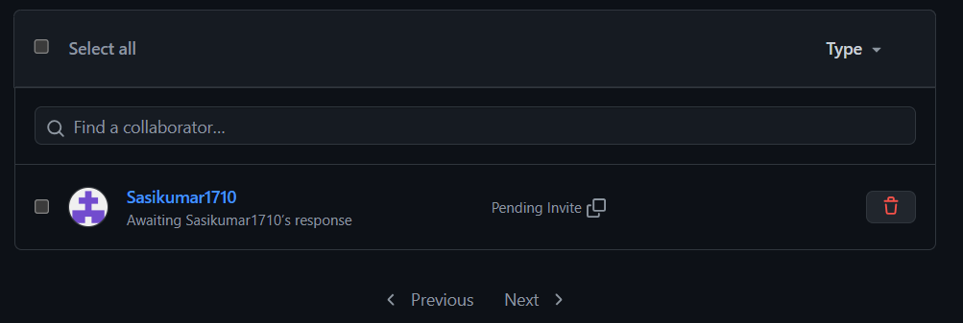

1. Next, everyone else in the group should **clone** the repository from GitHub. Verify that the context of the repository is what is expected.

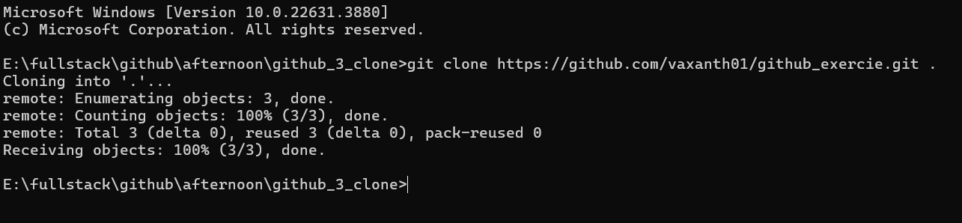

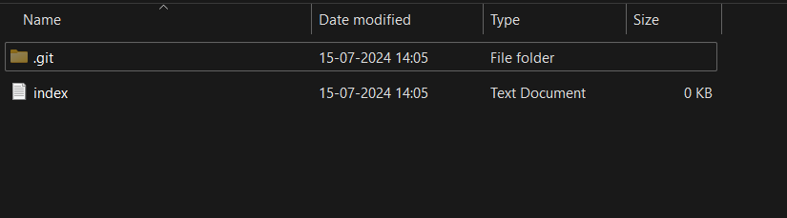

1. One of the group members who just cloned should now make a local **commit**, then **push** it. Everyone should verify that when they **pull**, that commit is added to their local repository (use **git log** to check for it).

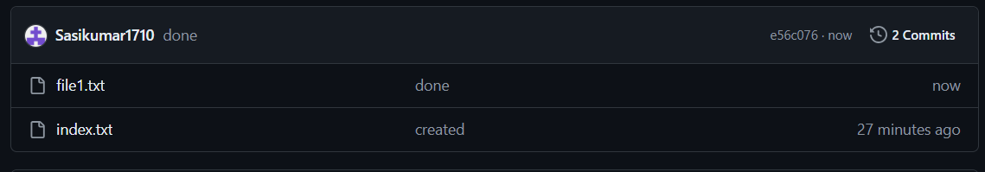

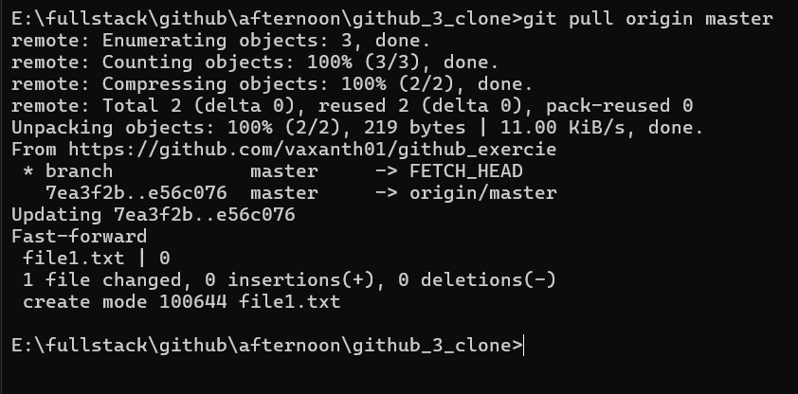

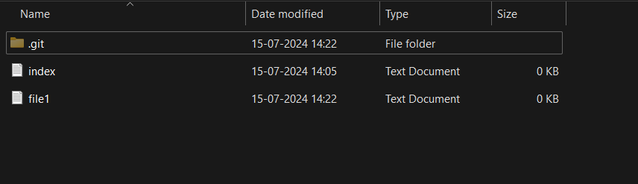

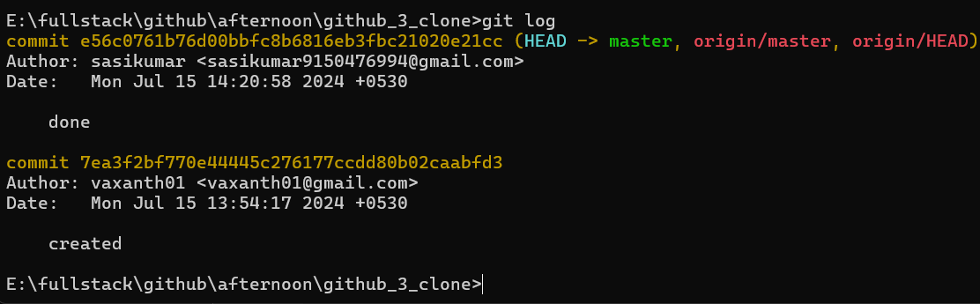

1. Look at each other’s **git log** output. Notice how the SHA-1 is the same for a given commit across every copy of the repository. Why is this important?

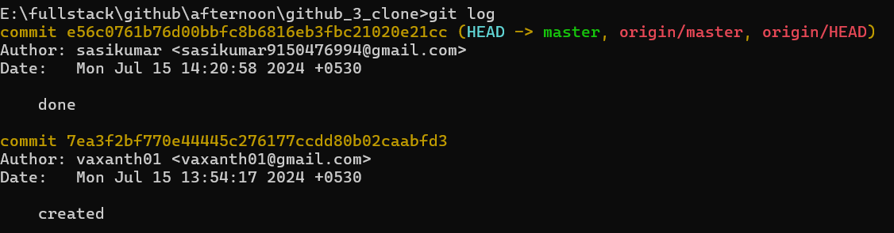

7. Two members of the group should now make a **commit** locally, and race to **push** it. To keep things simple, be sure to edit different files. What happens to the runner-up?

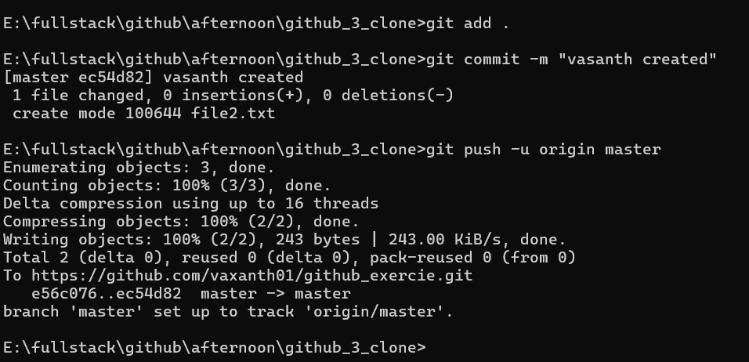

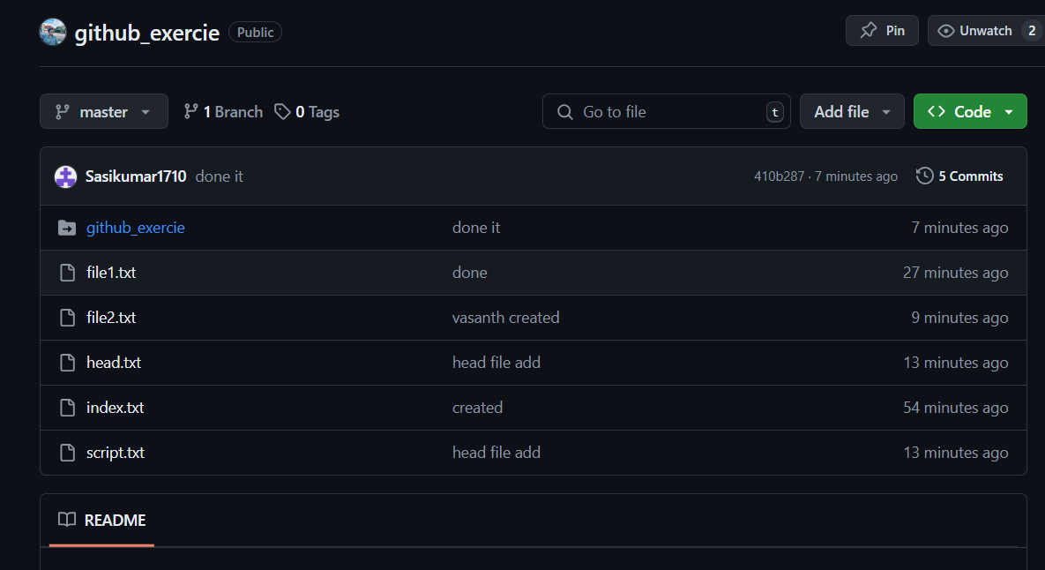

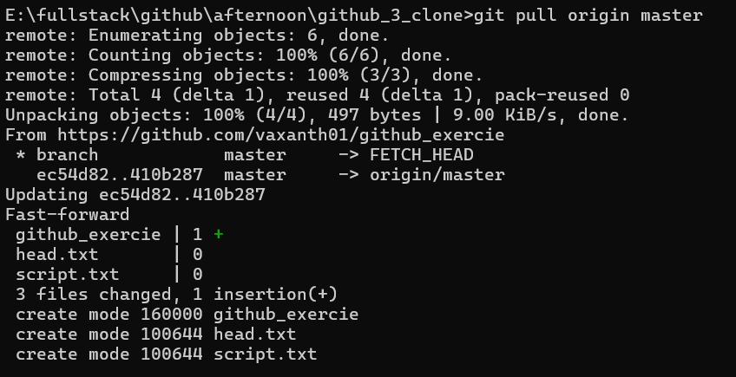

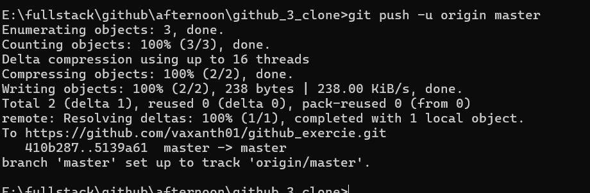

1. The runner-up should now **pull**. As a group, look at the output of the command. Additionally, look at the **git log**, and notice that there is a merge commit. You may also wish to view the DAG in **gitk**.



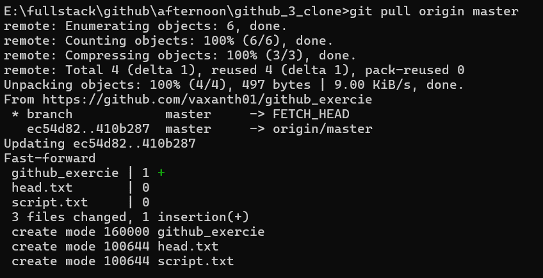

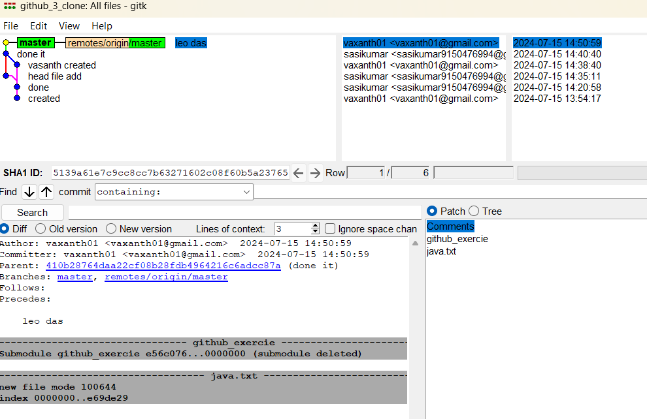

1. Repeat the last two steps a couple of times, to practice.

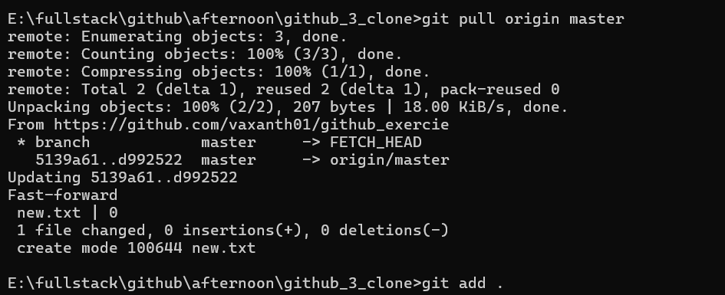

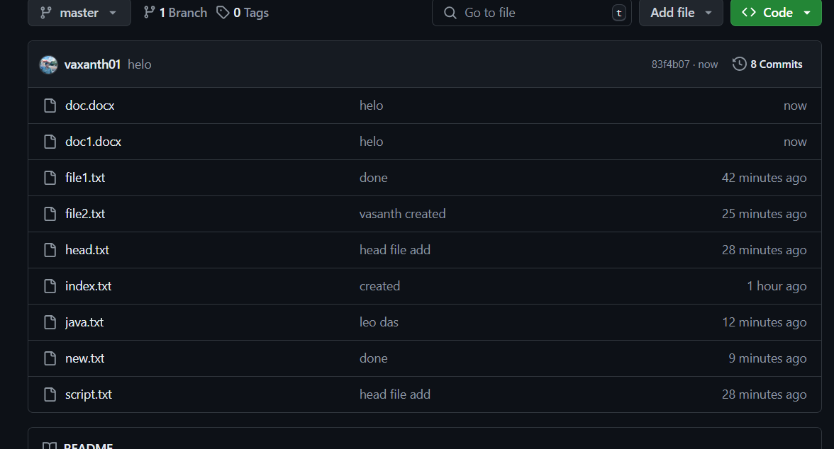

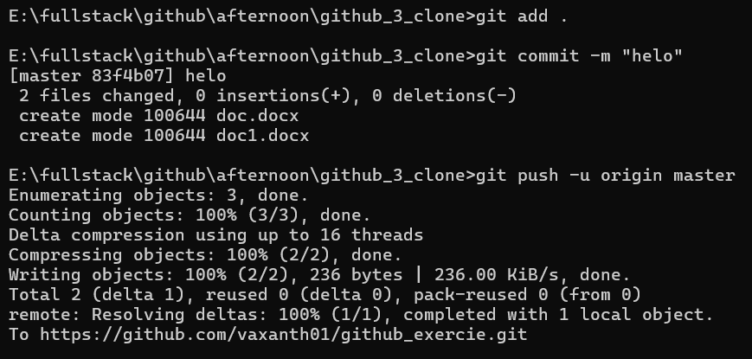

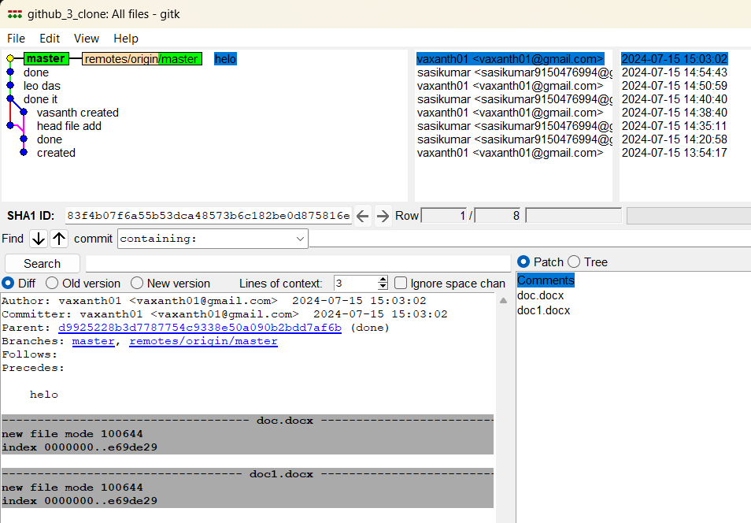

**Exercise 4**

**Main Task**

1. Make a commit, and make a silly typo in the commit message.

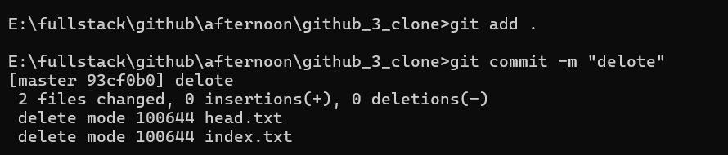

1. Use the **--amend** flag to enable you to fix the commit message.

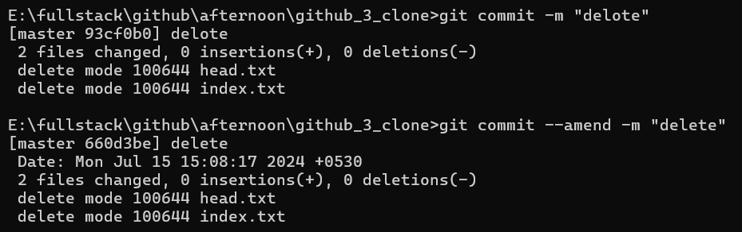

1. Look at the **log** and notice how the mistake is magically gone.

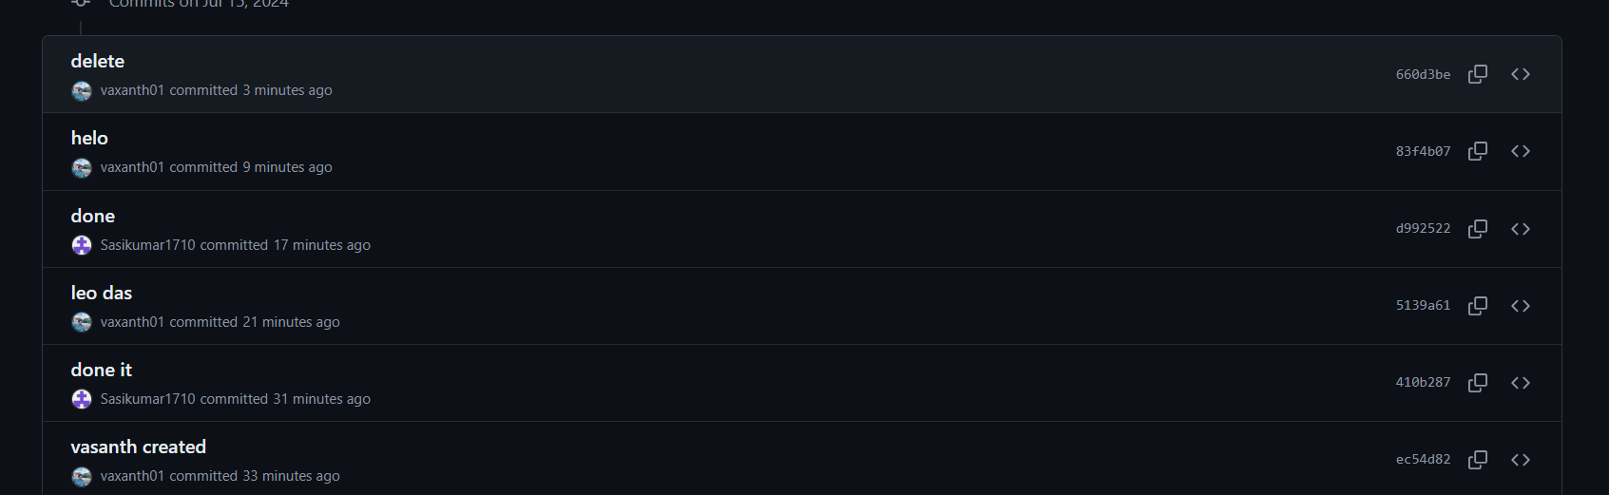

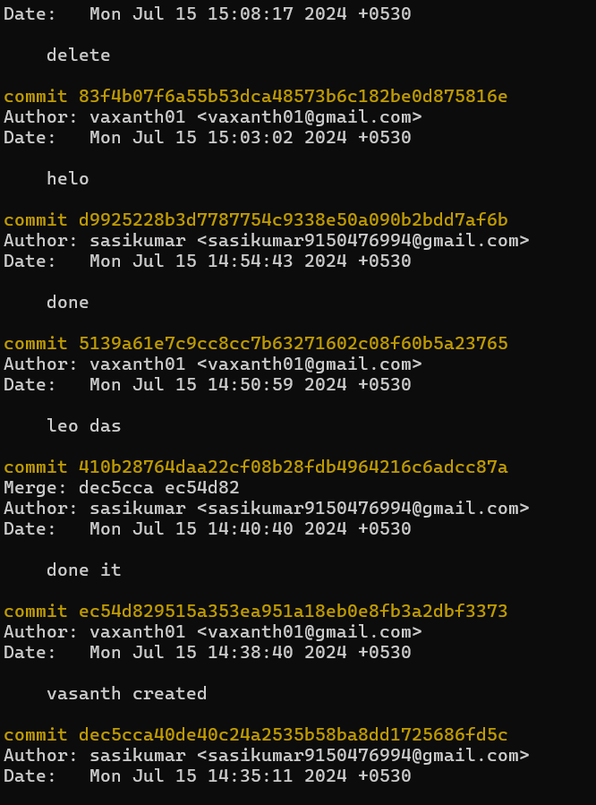

1. Now make a commit where you make a typo in one of the files. Once again, use **--amend** to magic away your problems.

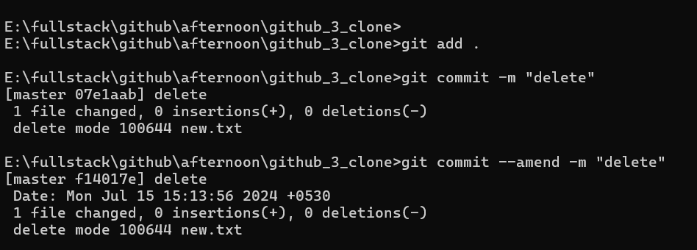

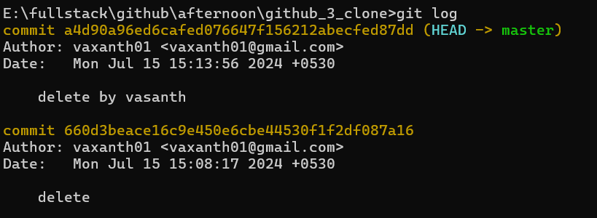

1. Create a branch. Make a commit.

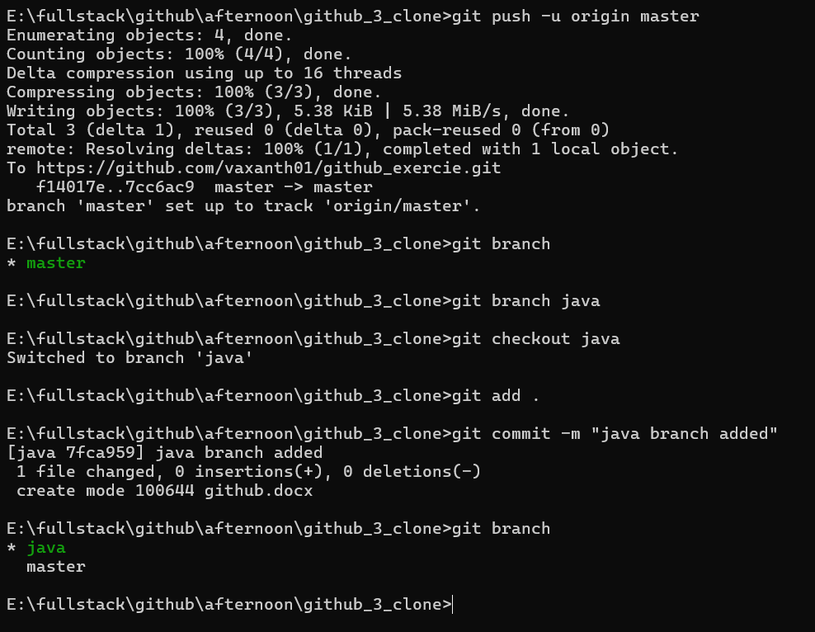

1. Now switch back to your master branch. Make a (non-conflicting) commit there also.

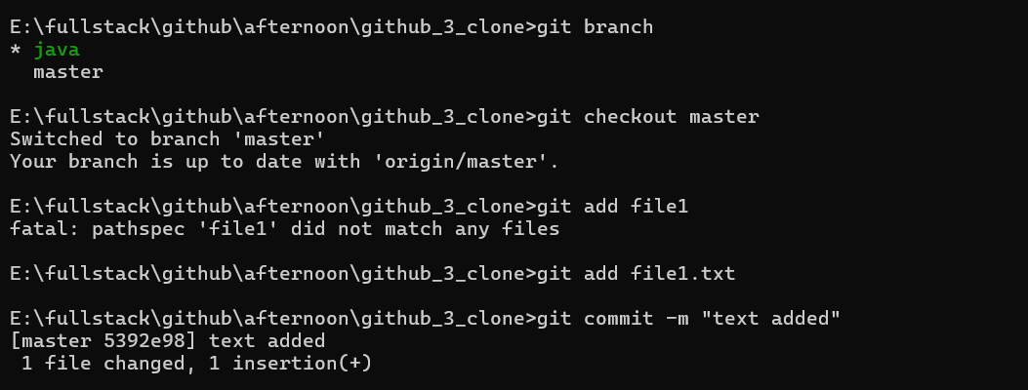

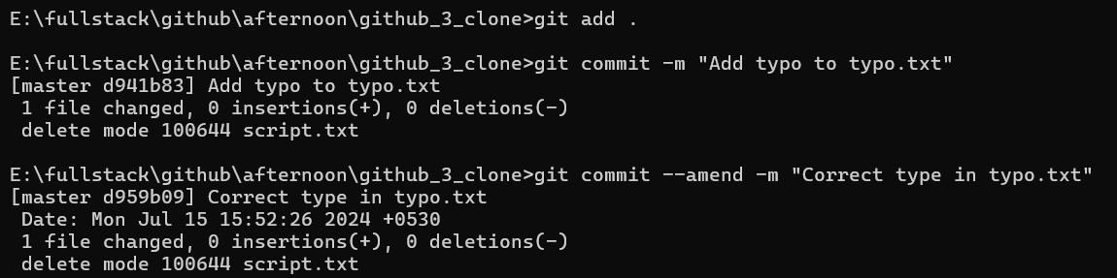

1. Now switch back to your branch.

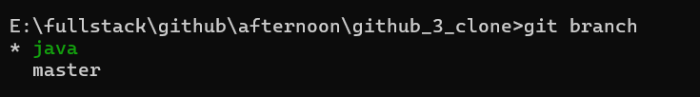

1. Use the **rebase** command in your branch. Look at the DAG in **gitk**, and note that you have the commit from the master branch, but no merge commit.

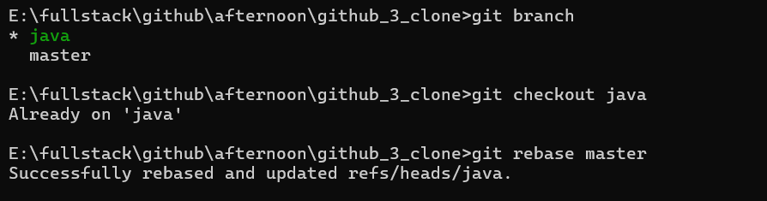

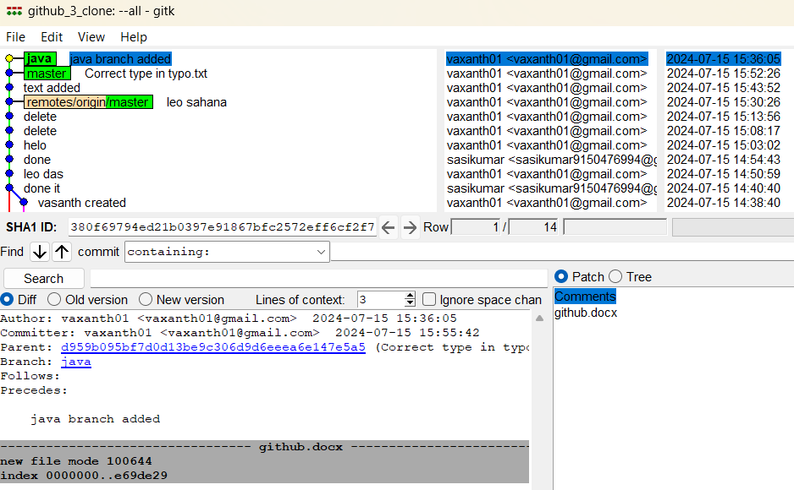

1. Make one more commit in your branch.

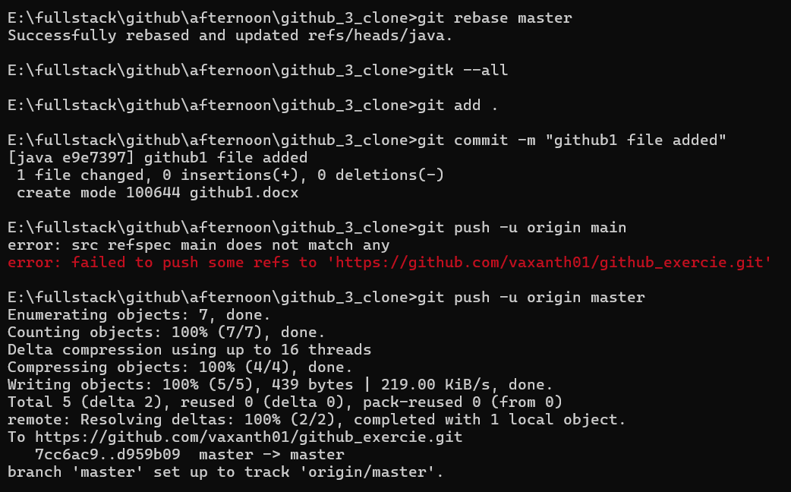

10. Return to master. Merge your branch. Notice how, thanks to the rebase, this is a fast-forward merge.

